**Hands-On Lab**

## z/OSMF Diagnostic Assistant

## Abstract:

IBM z/OS Management Facility (z/OSMF) provides a web-based UI to allow you collect z/OSMF diagnostic data with 1 click, set log level, and manage z/OSMF data repository space.

In this hand-on lab, you will explore the new z/OSMF Diagnostic Assistant task to get familiar with how to do z/OSMF diagnostic such as collecting diagnostic data from z/OSMF GUI.

This session will be useful for you to manage z/OSMF servers especially when diagnostic data needs to be collected for z/OSMF problem analysis.

**z/OSMF Diagnostic Assistant lab:**

In this lab, you will learn about collecting z/OSMF diagnostic data via the new z/OSMF Diagnostic Assistant task by completing the following activities:

1. Log in to z/OSMF

2. Open z/OSMF Diagnostic Assistant task

3. Collect and export z/OSMF diagnostic data

4. Check out the exported package of z/OSMF diagnostic data

5. Set log level

6. Clean up diagnostic data

7. Monitor space usage of z/OSMF data file system

As with the other labs in this session, the lab teams share access to the same z/OS system. Each team is given a unique z/OS user ID to use for the exercises. To avoid confusion, use only the user ID that is assigned to your team.

**Notes:**

1. The screen captures in this handout show the use of different user IDs. Your browser session will use the user ID that was assigned to you.
2. Log in to z/OSMF

* Launch browser from your workstation
* Point browser to z/OSMF – enter the following url

<https://share.centers.ihost.com/zosmf>

* Login with the userid/pw as provided by the lab instructor
* Each workstation will be assigned a unique z/OS user id

Note: All screen captures in the handout show user ID “shara01”, your browser will be slightly different to reflect the User ID that you were given.

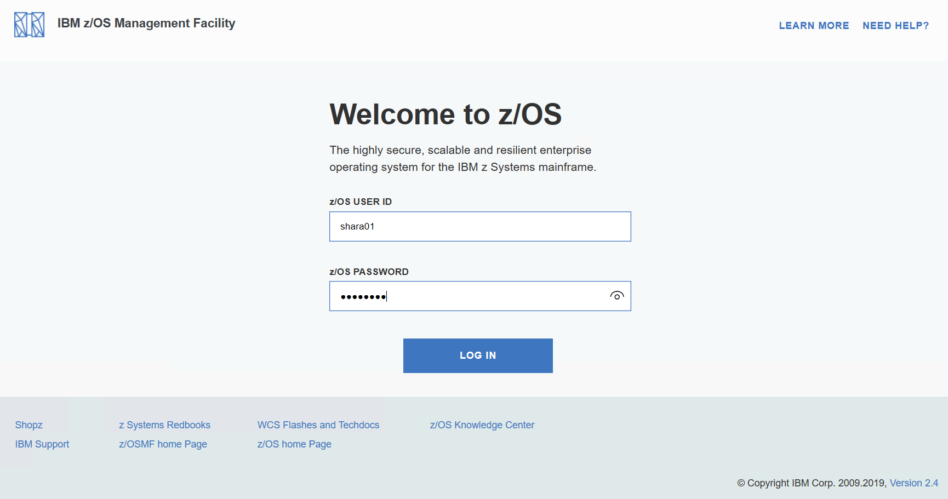

Input user ID and password that provided by the lab instructor, then you will enter the z/OSMF Desktop UI:

1. Open z/OSMF Diagnostic Assistant task

Find icon of App Center which is on the left bottom of the z/OSMF desktop:

Click on the icon of App Center. When App Center window is opened, find the icon of z/OSMF Diagnostic Assistant task. Try to hit key “Z” to quickly locate icons start with “Z”.

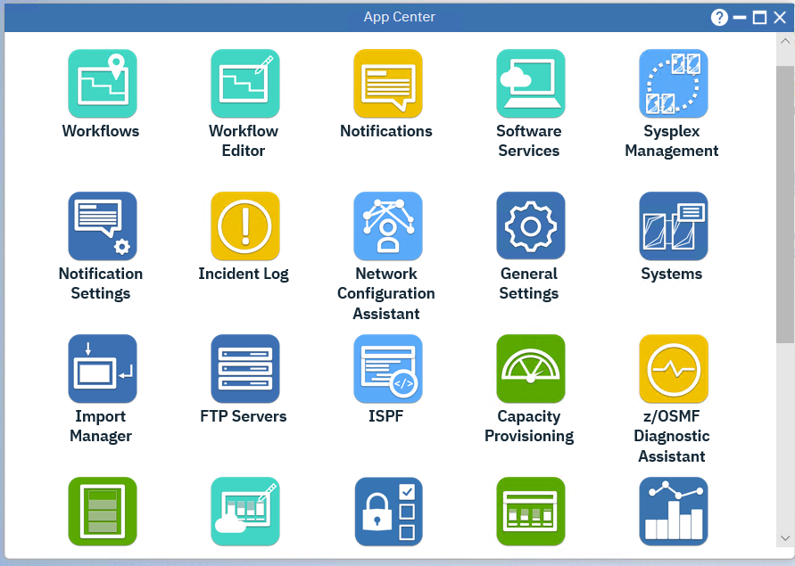

Double click on the icon of z/OSMF Diagnostic Assistant. z/OSMF Diagnostic Assistant will be opened in a separate window.

There are a couple options of different z/OSMF diagnostic data for user to choose. In this hands-on lab, we will select the option “Only include runtime and server side logs” to reduce the time you need wait for download to complete.

1. Collect and export z/OSMF diagnostic data

Ensure the checkbox “**Only include runtime and server side logs”** is selected, thenclick **Export** button:

Once you click Export button, z/OSMF starts to collect specified diagnostic data and compress the package. There will be a progress bar to display the current Export progress.

When the compressed z/OSMF diagsnotic data is downloaded to your workstation successfully, browser will prompt you for further action. The package of z/OSMF diagnostic data is named by the time stamp when you choose to collect the data.

1. Check out the exported package of z/OSMF diagnostic data

Now find the download icon of your browser and open the download list. Click **Open** to view the package generated by z/OSMF Diagnostic Assistant

Click folder **logs** to view the log details as below.

1. Set z/OSMF Logging level

In z/OSMF Diagnostic Assistant, select the tab **Set the z/OSMF logging level**.

The services table shows the z/OSMF services for which the log level can be set. Initially, the table is empty. To modify the log level for a particular z/OSMF service, you must first add the service to this table.

To add a z/OSMF service to the table, select **Add service**.

In the Add Service window, select the z/OSMF services for which you want to modify the log level, you can select “ z/OS dataset and files …”

Click **OK**.

The services table is updated to show the package name and current log level for the z/OSMF services that you selected.

For each z/OSMF service, you can specify the log level with the dropdown list on the right side. You no longer need complex system command to change z/OSMF logging level. **Since you are operating with a shared system, we won’t click Save button to save the settings.**

If you want to restore the defaults setting, you can select **Restore defaults**.

1. Clean up diagnostic data

In z/OSMF Diagnostic Assistant, select tab **Space management** to manage the automatic removal of z/OSMF diagnostic data.

In Space management, you can enter the number of days in **Remove log files older than (days)**. In this system, administrator sets it as 60. When a file’s age is greater than the age criterion, the file is a candidate for removal.

You can select the log file types that you want to remove. Files that meet the age criterion are removed only if you specify the daily removal policy or if you specify immediate removal. In this system, administrator select all log file types.

You can set the **Activate this policy (log files will be removed every 24 hours based on your selections)** checkbox if you want to every day check for and remove log files that meet the age criteria.

You can set the **Remove immediately** checkbox if you want to immediately remove log files that meet the age criteria.

**Since you are operating with a shared system, we won’t click the “Set” button.**

**Now, close the z/OSMF Diagnostic Assistant window.**

1. Monitor space usage of z/OSMF data file system

Double click on z/OSMF Desktop and display the z/OSMF Desktop task bar in the bottom. There is a space monitoring icon, which indicates the percent usage of the z/OSMF data directory.

Click the space monitoring icon to display a tooltip. If z/OSMF data file system is full, you might experience failure of z/OSMF functions. This monitoring function could help you to get informed and therefore, avoid such situation happened.

## Exercise review and wrap-up

In this lab, you became familiar with the new z/OSMF Diagnostic Assistant task by completing the following activities:

1. Log in to z/OSMF

2. Open z/OSMF Diagnostic Assistant task

3. Collect and export z/OSMF diagnostic data

4. Check out the exported package of z/OSMF diagnostic data

5. Set log level

6. Clean up diagnostic data

7. Monitor space usage of z/OSMF data file system

